B3.1 Pre-Unit Quiz
- The diagram below shows a cell.
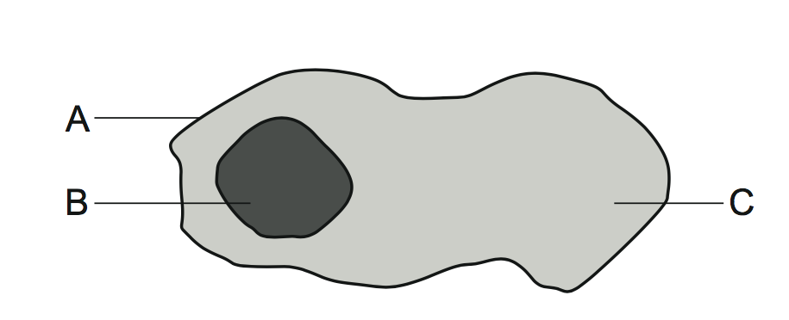
- What is the name of the part labelled A? [1]
Tick ( ) one box.
- Cell wall | 
- Cytoplasm
- Cell membrane
- What is the function of the part labelled B? [1]
Tick ( ) one box.
- Controls what enters and leaves the cell
- Contains DNA and controls activities in the cell
- Makes food for the cell using light

- Which statement is correct about cytoplasm? [1]
Tick ( ) one box.
- Cytoplasm is only found in animal cells
- Cytoplasm is only found in plant cells
- Cytoplasm is found in both animal cells and plant cells
- A type of yeast is used to bake bread. The yeast is made of
single cells. Which statement best describes these yeast cells? [1]
Tick ( ) one box.
- Yeast is a unicellular organism
- Yeast is a multicellular organism
- Yeast is made of plant cells
- A student uses a microscope to magnify a specimen from a leaf.
Iodine solution is used to stain the specimen. The drawing below shows
what the student saw in the microscope.
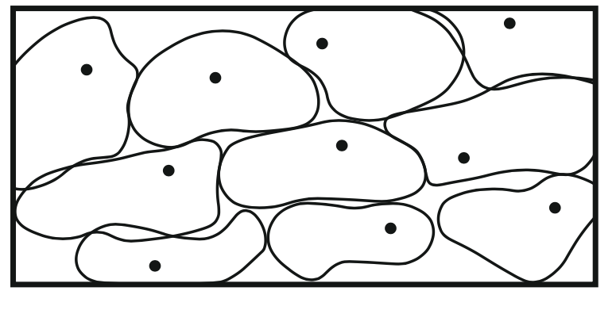

- Describe how this scientific drawing could be improved. [1]
Tick ( ) one box.
- Draw more cells so more of the tissue can be seen
- Increase the magnification
- Add labels for the nucleus, cell membrane and cytoplasm
- Why are microscopes needed to see cells? [1]
Tick ( ) one box.
- Cells are see-through so cannot be seen by eye
- Cells are too small to be seen by eye
- Cells can only be seen on a slide
- How would the student magnify one cell to study it in more detail? [1]
Tick ( ) one box.
- Move the coarse focus wheel
- Change the eye piece lens to a greater magnification
- Change the objective lens to a greater magnification

- The student thinks that the dot seen in each cell is a chloroplast.
Do you agree with the student? [1]
Tick ( ) one box.
- Yes
- No
- Need more information
- The diagram below shows a cell called Euglena.
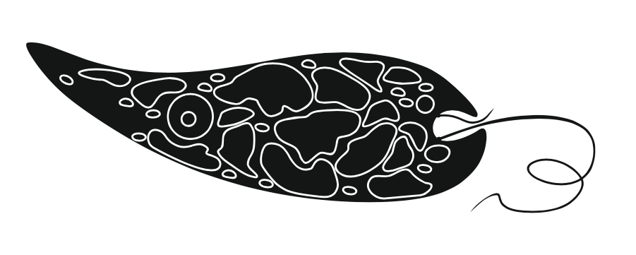
- How is the cell adapted for moving? [1]
Tick ( ) one box.
- It has a tail
- It moves to get food
- It is a sperm cell

- The cell makes food using sunlight.
Which part of the cell carries this process out? [1]
Tick ( ) one box.
- Cytoplasm
- Chloroplast
- Vacuole

